Date | 30 September 2026
Team ID | 6ab4dd7a6f290be8a6b49f92
Project Name | Script-Controlled ACL – Restrict Record Access Based on Field Value
Maximum Marks | 3 Marks

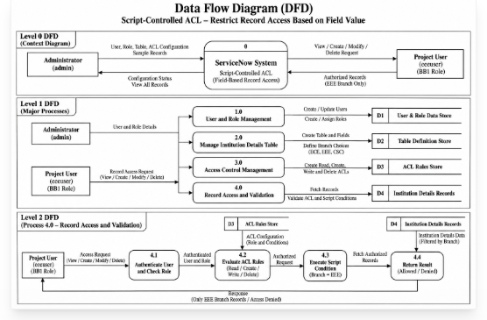

DFD (Data Flow Diagram) – Description
The Data Flow Diagram (DFD) illustrates how user requests and record information flow through the ServiceNow ACL security system. The Administrator configures users, roles, the Institution Details table, records, and Access Control Lists. When the Project User requests access to a record, ServiceNow checks the assigned role and evaluates the configured ACL rules, including the Branch-based script condition. The system then either authorizes the request and displays the permitted record, such as the EEE record, or denies the request when the access condition is not satisfied. This process ensures that Institution Details records are protected according to the defined security rules.

